https://validator.nu/?doc=https%3A%2F%2Fbthoma-su.github.io%2Fist263%2Flab04%2FContact.html
https://bthoma-su.github.io/ist263/lab04/Contact.html
https://bthoma-su.github.io/ist263/lab04/Skills.html
https://validator.nu/?doc=https%3A%2F%2Fbthoma-su.github.io%2Fist263%2Flab04%2FSkills.html

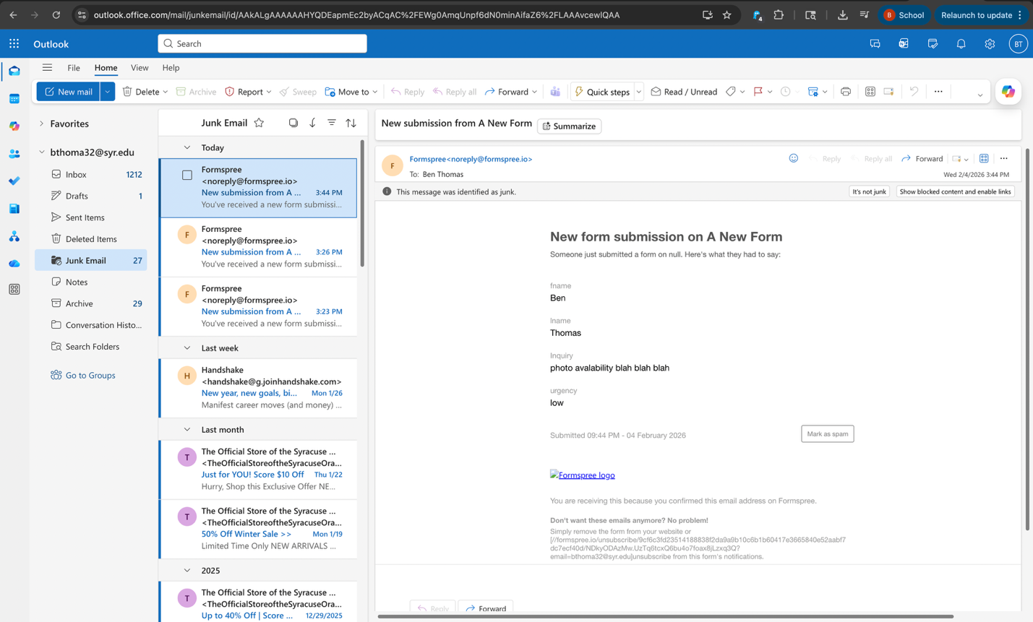

- No questions about the lab
- Hardest part was adding another section for the form for me cause initially it was stuck all under last name
- 2

